**Welcome to the DCFS University Training Center**

**USC Building**

*(Off Campus Location)*

# S. Hill St., 8th Floor Los Angeles, CA 90015

**213-497-4200 ext. 200**

***Welcome Trainers, Trainees, and Visitors!*** *We look forward to seeing you at our training center in Downtown Los Angeles.*

## Parking and Entrance to Building (map attached)

Parking is located at 150 W.12th St. (Broadway Garage). There are entrances on Hill St., Broadway, and Pico. ***Pull a parking ticket to enter the structure. Pay for parking at the parking machine on level 1 before returning to your vehicle or you may pay by credit card at the exit lanes.*** Most available spaces are on level 4 and above. We advise you to make note of the parking level where you parked.

**\*CSW Core Academy social workers will be provided parking validation for the duration of their respective Academy.**

**(Please Note: There is no in and out for the parking structure. Those entering before 9:00AM pay the early bird rate of $15; Entering at 9:00AM or after, parking rate is $25. Visitor’s please check with your County Department or Agency regrading reimbursement. We cannot reimburse any parking fees at the center.**

Enter the USC Building from the Hill Street side. In the lobby is a concierge desk. Give them *your name*, and that you are here for *“Training/Meeting/Event title”*. The attendant will give you a name label and access to the 8th floor.

**Water:** Any non-drip water-drinking container with closeable lid is permissible within the classroom. For your convenience, a water cooler dispenser & cups are provided outside of **Classroom 1 and 5**, near the white cabinets. We appreciate the consumption of other beverages, like coffee and juice, outside the classroom.

**Snacks:** If you bring snacks, please enjoy them outside the classroom during your morning and afternoon breaks. We appreciate your understanding.

**Lunch:** You are welcome to bring a lunch with you every day you are to report to the Training Center. We provide refrigerators and microwaves, though limited, for your convenience directly outside of classrooms.

When you are dismissed for lunch, please proceed to the 1st Floor or the Garden Level (GL) of the building. Both have open seating areas, free Wi-Fi, & flat screen TVs. More space is located on GL and the Outdoor Garden areas. You may also purchase your lunch & refreshments at the following eateries in the building:

|  |  |
| --- | --- |
| **1st Floor:**   * Trimana * Cilantro * Miffies | **GL (Level):**   * Market Cafe |

**Restrooms** are located on the 8th Floor near the elevators and on the 1st Floor Rev. 7/11/2025

**Welcome!**

The **DCFS University Training Center** is located in downtown Los Angeles inside the USC Building (Off Campus Location):

**1149 South Hill Street**

**Suite H800 (8th Floor)**

**Los Angeles CA 90015**

The following information is provided to assist you in your upcoming visit.



The multi-level parking structure for the USC Building is located at **Hill Street** on the corner of Hill and 12th Street

(150 W. 12th Street) labeled, “Public Parking”. **Please obtain a parking ticket and self-park. Pay parking fee at the Parking Machine located on level 1 before returning to your vehicle or pay by credit card at the parking exit lanes. The parking fee is $25** **per day *(If entering prior to 9:00 AM, early bird parking fee is $15).***

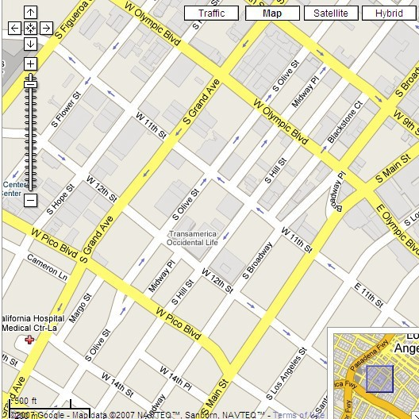

USC Building 1149 S.

Hi

l

l St.,

8

th Floor



**Parking**

The USC building has security coverage 24 hours a day / 7 days a week. All tenants must submit the names of all guests. When you arrive, see the security desk.

A picture ID is required to check-in. You will receive a sticker ID badge which you will need to return to the security desk when you leave.

Rev. 7/11/2025

# Parking Rules and Regulations

From: DCFS Training Center

Dear Trainees and Visitors:

Please be advised of the current parking Garage Rules and Regulations. As a user of the garage, we request that you follow any instructions provided by parking personnel and/or posted throughout the garage.

South Park Rules and Regulations are as follows:

* ABM Onsite Services and/or Building Management are not responsible for contents of vehicles parked in the facility. Please do not leave valuables in plain view.

* There is a maximum speed limit of 5 MPH in the garage. Always look for pedestrians while in the garage and slow down at the end of ramps and by the elevator areas. Observe all stop and speed limit signs. Also, look for other vehicles that might be backing up.

* Park only in designated spaces within the marked compact stalls. Always park “head-on”, rear-end parking is not allowed for safety reasons.

* No overnight parking is allowed unless it is authorized by Building Management. If permission granted, vehicle owner will assume all liability.

* Handicapped stall usage is strictly monitored. Parking enforcement routinely inspects for permit compliance.

* Any damages that occurred in the garage must be reported in writing to the parking office or building security before leaving the facility.

* If valet parking services are used, vehicles will only be released to owners, unless an authorized release is submitted to the parking office.
* No authorized outside services such as: mechanical repairs, tune-ups, oil changes, window tinting, installation of any equipment such as stereo and car alarm, washing, detailing, etc. is allowed on the premises.

1

* The use of electric charging stations is available on a first-come, first-served basis. Vehicle charging is limited to a maximum of four (4) hours per day. The use of any charger is not intended as an all-day parking area. Violators will be subject to be towed at vehicle owner's expense. Vehicle owner is responsible for plugging and unplugging the vehicle into and from the electric charger in the vehicle. The use of outlets throughout the garage to charge an electric vehicle is not allowed.

Please contact the Building Management Office at (213) 741-7400 should you have any questions or concerns.

Kind Regards.

2